**xPression Design Installation**

**Long Term Care Group (LTCG)**

**Version 2.0**

**Version History:**

|  |  |  |  |  |
| --- | --- | --- | --- | --- |
| **Version No.** | **Date** | **Prepared By** | **Reviewed By** | **Approved By** |
| 1.0 | 29-Mar-2016 | Dinesh Kumar | Chandra Sekar |  |
| 2.0 | 20-Apr-2016 | Dinesh Kumar | Samatha |  |

**Installation Steps:**

1. Map the Network Drive \\mnepapp81-d\xPression as ‘X’ drive in your LTCG VDI. To map this network drive, goto My Computer, Select the Drive as “X” and enter the Folder path as “\\mnepapp81-d\xPression”

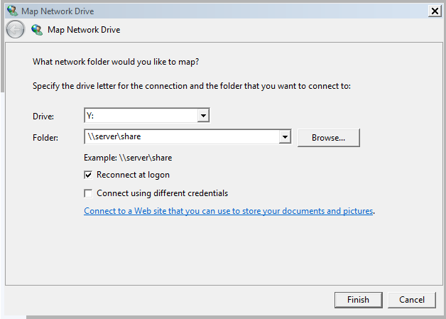

1. Go to the path: **X:\Apps\xDesign.net_Installer** and double click on the “Setup” Application icon

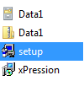

1. The xDesign installation wizard will be started. Select the installation path from the window. By default it will choose the ‘C’ Drive. Click “Next” Button

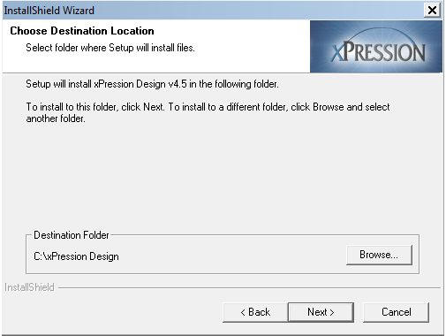

1. Select the Type of Setup you prefer. By default it will be “Typical”. Better go with this setup and click on “Next” button

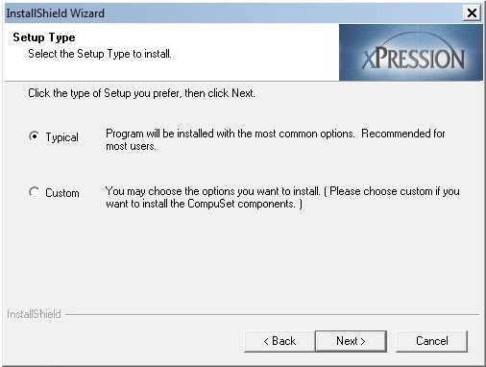

1. Enter the Application Server Platform and xPression server details as mentioned in the below screenshot and click on “Next” button

|  |  |
| --- | --- |
| Application Server Platform | JBOSS |
| Connection Method | Servlet |
| xPression Server Descriptive Name | Development |
| Server Name | mnepapp81-d |
| Port Number | 8080 |

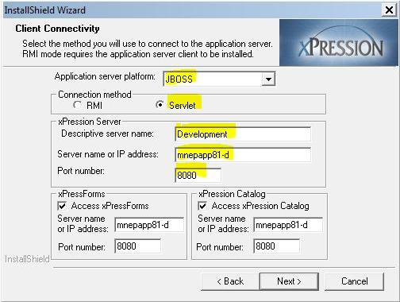

1. Once the installation is successfully completed, the system will prompt to restart the machine. You can use the xDesign once the system is restarted.

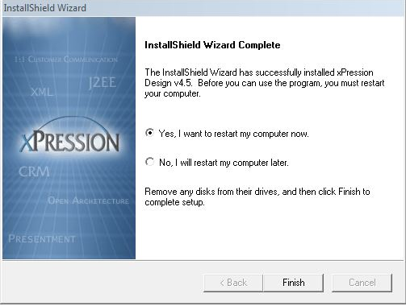

1. Once the installation is done, replace the existing **servers.xml** file with the attached one in the path: **C:\xPression Design**



**Note:** Contact the Project Team if you face any issues during the installation process.